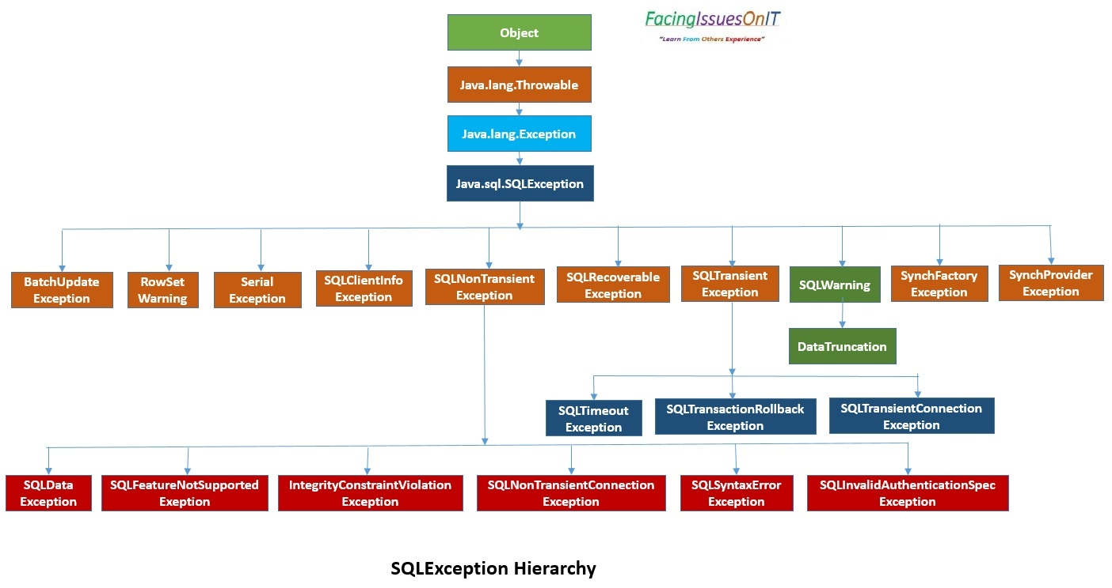
FacingIssuesOnIT
Object
"Learn From Others Experience"
Java.lang.Throwable
Java.lang.Exception
Java.sql.SQLException
BatchUpdate Exception
RowSet Warning
Serial Exception
SQLClientInfo Exception
SQLNon Transient Exception
SQLRecoverable Exception
SQLTransient Exception
SQLWarning
SynchFactory Exception
SynchProvider Exception
DataTruncation
SQLTimeout Exception
SQLTransactionRollback Exception
SQLTransientConnection Exception
Exception
SQLData SQLFeatureNotSupported IntegrityConstraintViolation Exeption
Exception
SQLNon TransientConnection Exception
SQLSyntaxError Exception
SQLInvalidAuthenticationSpec Exception
SQLException Hierarchy

